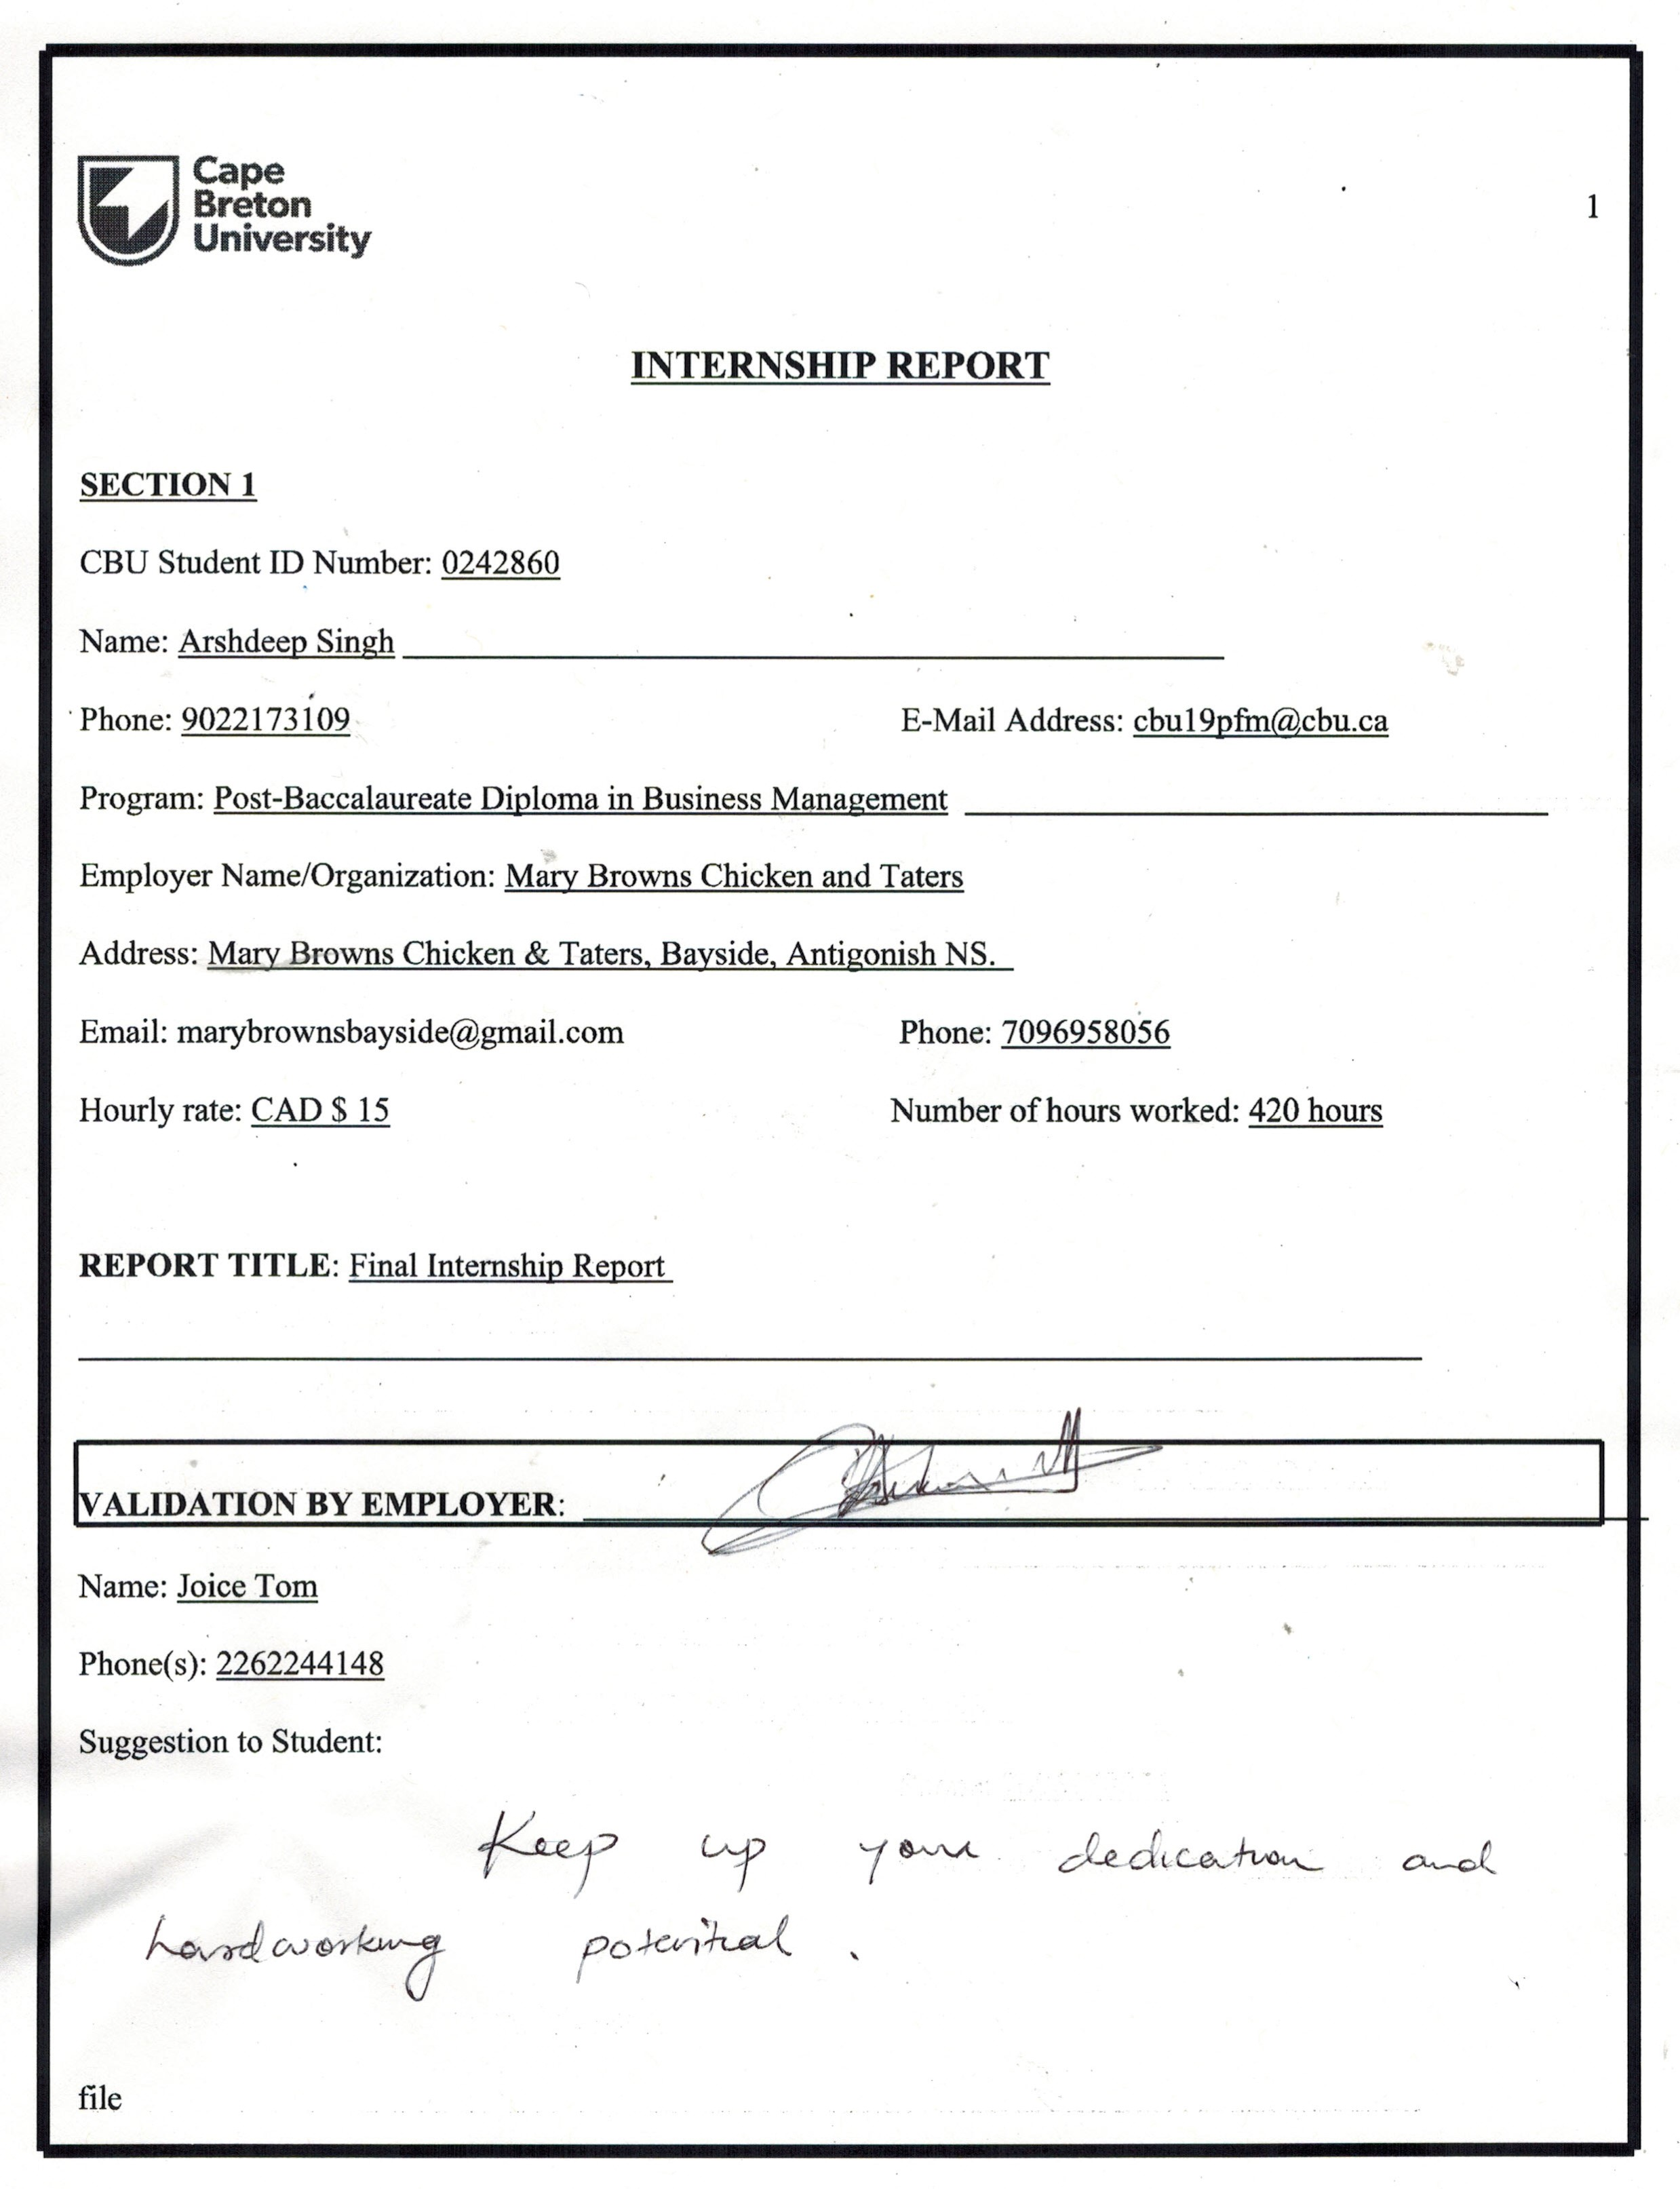ga

**REPORT DESCRIPTION**

**ABSTRACT**

The Internship is an essential part of my study. I have learnt too many things during my internship. An internship is a professional learning experience in the concerned organization. An internship gives chance to apply theoretical knowledge practically. This was a great experience working with the Mary Browns. After completing my four semesters of theoretical learning, I was given a chance to enhance my knowledge by working in an organization. I choose Mary Browns to work with for my internship.

I feel glad to be a part of Mary Browns. The organization provide a familiar environment to its employees and learners as well. I have studied so many topics or courses related to business management, the internship is a combination of all of them. Every learning is applicable in an organization from all perspectives.

This report is all about my experience including my achievements, challenges, and learnings in an organization. I am going to divide my report into different sections to explain it better. This report is a brief overview of my journey at Mary Brown.

The report will also include the tasks and duties performed by me, accomplishments, positive and negative points at work, my improvements etc. in detail.

**INTRODUCTION**

I have completed my interesting days’ internship at Mary Brown. It is a company which deals with food items. I have learnt so many new things while working on it. Besides this, I improved many skills which were not flourished yet. The internship was my training as well as a working period with a great organization.

**COMPANY AND POSITION OVERVIEW**

Mary Brown is a famous and well-established Canadian fast-food restaurant. Its full name is Mary Brown Chicken. It is famous for its fried chicken and plant-based chicken. Mary Browns is covering more than 200 locations in Canada. Its main dishes include potatoes, coleslaws, sandwiches, and tenders.

Mary Browns is an old company in food chain restaurants. It was established in 1969 by Pat Tarrant and Cyril Fleming. It was the first fried chicken restaurant in Canada, so it did not take time to grow up rapidly. Mary Brown’s first restaurant was opened at St. John's Avalon Mall. For some legal reason, the name of Mary Browns was changed to Mary Browns Virginia Chicken.

The CEO of Mary Browns is Gregory Roberts. Gregory Roberts acquired the ownership in 2007 with 67 restaurants and brings it to over 200 stores in Canada. It is a great achievement.

Mary Browns uses two slogans-

* “Made Fresh from Scratch”
* “100% Canadian”

I joined Marry Browns in mid-September for my Internship purpose. I am a member of the multi-tasking staff. I performed different tasks in different positions such as Cook, Prep, Cashier, Packager etc. I have learned so many things by working in these positions.

**PUTTING THEORY INTO PRACTICE**

I was very excited to join Mary Browns for my internship purpose. I have heard many good reviews about the company from my friends and its ex-employees. Mary Browns owns high goodwill in the market. It was a great opportunity for me to work with such a popular organization. I was excited about my learnings and experience with Mary Brown. Mary Browns gave me more prominent things than I expected.

I did not face any major difficulty in my internship as I have learnt various concepts in my courses. It is the best-suited option to enhance my knowledge by applying theory to practice. Further, I will show how I used my learnings from courses in the Internship-

The concepts of accounting which I learnt from accounting courses proved useful for my cashier position as well as inventory control. The job of inventory control seems joyful to me. I apply the FIFO method for stuff and other inventory. I learnt this concept in my accounting course. It means first-in-first-out. The stuff made or purchased first, consume first. This concept is helpful to avoid wastage and spoilage of food.

Another course is marketing. This course is supportive of my internship. Its key concepts help me increase restaurant sales through different mediums. It also taught me to advertise items. Furthermore, the marketing course taught me to work with cooperative and friendly nature in the organization.

I used the concepts of management in every position. At the cashier, to handle cash and also to handle orders from customers from different mediums. As the cook, systematically prepare food items by arranging stuff. Prep includes the pre-cooking process. It includes cleanliness and sanitizing of equipment and work area. And the arrangement of stuff by keeping them fresh. To keep all the stuff containers full. Furthermore, the other position is packager. It is all about arrangement. It needs concentration while packing food and delivering it to a particular customer.

**KEY ACCOMPLISHMENTS**

This internship is helpful to learn various skills. The key skills are-

1. Communication
2. Management
3. Co-operation
4. Co-ordination
5. Time management
6. Work at a pace
7. Culinary skills
8. Accounting
9. Sales Executive
10. Concentration
11. Hospitality
12. Tagging of stuff

Moreover, I am going to explain in detail my accomplishments at my internship. This will include what I learnt within the period of the internship. Accomplishments are as follows-

* **Culinary skills**

The first and foremost skill which I am going to talk about is culinary skills. It is a skill related to cooking and pre-cooking. I did not ever experience cooking before. This was my first experience with a restaurant. I was nervous to face challenges in the restaurant, but it was a very interesting and knowledgeable experience.

It includes cleaning equipment before starting the process of cooking. After that, the responsibility of the cook is to wash chicken and potatoes into small and standard-sized pieces. Then, the process of marination is performed on the cut pieces of chicken and taters. Potatoes are called taters. After the marination, the stuff is stored in coolers to keep them fresh for a long time. A special kind of salt is used at different stages of the cooking procedure to avoid spoilage of the stuff.

Cutting off chicken and taters needs high concentration. It is necessary for safety from harm as well as cutting in proper sizes as mentioned in Mary Brown guidelines. Even all the process of cooking, prep and other tasks is an attempt as per the guidelines provided. The pace is important in the process of cooking to meet the demand of the customers. The cook has a responsibility to prepare food on time as per the requirements of the customer and deliver it to the customer in proper conditions.

* **Time Management**

Time management is important for any kind of work. It plays a pivotal role in this work and also in different traits. It does not only include management of time but also punctuality at the work. It can be seen in the shift system. Mainly the cook has to reach 2 hours before the opening of the restaurant for management of all the things and to keep food items ready before the customers start arriving.

I want to mention that my main and favourite skill is time management, which I learned during my internship. There is a heavy workload at every position due to the goodwill of the restaurant. It encourages us to do work with speed without wasting too much time on a single task.

We have to perform different tasks at a time and in a position. So, the pace is essential at work. Along with this, the safety and quality of food also matter. We do not compromise with these two aspects. Definite time is mentioned in the guidelines for each task. As we have to complete cutting 20 sacks of chicken and taters in one hour.

* **Communication**

The internship is helpful to improve my communication skills. I deal with different customers with a smile on my face. This skill is part of hospitality. It improves the brand image in public. It grows up the sales of the organisation.

I got a chance to explore many new things by working at the front desk. There are four methods to take orders from customers. I work with attention while working as a cashier. I got a chance to deal with diverse people. I always use calmness as a dealing head.

My behaviour is appreciated by everyone, both internal and external. It is a joyous achievement for me.

* **Co-operation and Co-ordination**

Both cooperation and coordination are necessary for the workplace. We all work with coordination without arguing with each other. It makes the environment of the workplace peaceful and friendly.

It also encourages us to do work with efficiency and effectiveness with a happy and healthy mind. I often used to do work by collaborating with my teams. There are many advantages of this such as a friendly environment, efficient and effective work, no wastage of time, better relations etc.

I work with diverse people. It gives me chance to know other cultures close. I became very passionate about my work.

* **Safety and Security**

The organisation taught me to keep safety as the main element at every work. It includes safety from cuts and burnings at the time of cooking. Mary Browns provides us with gloves by considering the safety of employees.

In addition to this, Mary Browns set guidelines for the safety of food. It is on its prime duty list. We have to check the quality of stuff from time to time and especially before preparing food. It is necessary to perform the task of tagging stuff as per their expiry dates and putting them in coolers to avoid spoilage.

Mary Brown set standards for the quality of food and we focus on them.

* **Accounting**

After completing my courses, the internship is the way to put the accounting concepts in practice which I learned during my courses. I did not get a chance to apply theoretical concepts in reality before.

Accounting concepts are used in the job of the cashier. It is also used at the time of management of stuff by applying the FIFO method.

**KEY CHALLENGES**

Challenges are part of a journey for acquiring knowledge and skills. I faced some challenges at the workplace. Challenges are important for the nourishment of a person to make him an expert in a particular trait. I am going to explain some major challenges with the help of the following points-

* The first challenge at the beginning for me was to cope with the workplace. As I told you earlier, I was a bit nervous at that time. But I took very little time to get mixed up with the environment of the workplace.
* The second most challenging task was to do work with pace. The pace is essential to prepare and delivering food to the customer on time. Initially, I was worrying to survive at the job because of this problem, but with time I improved myself and now, I can work at my pace and do not face any difficulty in handling orders.
* I faced difficulty in remembering the recipe for different items when I was new to the restaurant. There are so many ways to prepare a particular item.
* The other problem I faced was at the front desk while taking orders from four different sources at a time as well as receiving payments and cash handling.
* The most important part of the cooking process is cutting. It needs high concentration. It was a challenge for me to work on the saw machine.

**Future Plan**

It was a great experience with Mary Browns. As per my learning with Mary Browns, I decided to work further with the food chain industry to get more knowledge in this field. After taking experience for some more time, I will plan to start my business in my home town. I am watching myself in the position of a supervisor after some time and I will work hard to accomplish my goal.

**Conclusion**

The final report is all about my journey with Mary Browns Chicken and Taters during my internship period. I learn many things by facing some challenges and also learn to overcome these difficulties. Mary Browns is such a great company to work with. I enjoyed every moment of my learning with Mary Brown.